R E S O L U T I O N
WHEREAS It is the opinion of the Resolutions Committee that many persons outside of the public health profession have a great deal to contribute to public health thinking and programs; and
WHEREAS 'l'h e committee believes that formal invitationsto participate in Arizona Public Health Association meetings should be directed to representatives of organizations which have expressed an interest in public health; now therefore
BE IT RESOLVED That the ExecutiveCommittee of the Arizona Public H ealth Associationbe directed to invite representatives of these organizations to participate in the 1958 meeting of this associatio.n
Respectfully submitted RESOLUTIONS COMl.UT'lEE
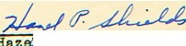•

P. Shields, Chairman

Albert Borza, Memb
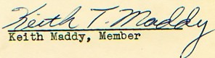
Presented to the Arizona Public Health Association May 8, 1957

•

